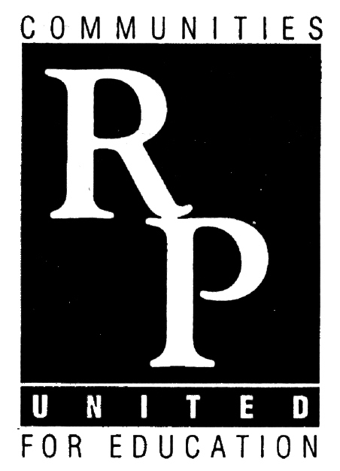

“Partners in Learning”

A Leadership in Energy & Environmental Design (LEED) GOLD Certified School

17509 East State Route 58, Raymore, MO 64083

Phone: 816-388-4000 * Fax: 816-388-4001
www.raypec.k12.mo.us

August 14, 2014

Dear Parents/Guardians:

Technology has become an essential part of education in the Raymore Peculiar School District. To be able to live, learn, and work successfully in our information-rich society, students must be able to utilize technology effectively. Many students’ lives today are filled with technology that gives them unlimited access to information and resources, enabling them to pursue their interests in their own way and at their own pace. The opportunities are limitless, borderless, and instantaneous.

In the past, student owned computing devices have been restricted from accessing the district’s network during the school day, yet we are well aware that students frequently use their own devices to complete school work while at home. With this in mind, the district has recognized the need to allow students to utilize their own technology in a more seamless way at school. In an effort to put students at the center of their own education and to empower them to take control of their own learning, the Raymore Peculiar School District is investigating an option that would allow students to use personal technology devices for educational use while at school.

During the 2014-2015 school year, we have several teachers at the middle school who will be participating in a Bring Your Own Device (BYOD) program and initiative. Students in these teachers’ classrooms will be able to bring their own mobile computing devices and access a filtered Internet connection that will be provided for educational purposes. At the current time, our records indicate that your student is currently enrolled in one or more of these classrooms.

In order for students to be eligible to participate in the BYOD program, parents and students will need to complete the process listed below:
- Parents need to read the district’s “BYOD Acceptable Use Policy”. A link to this policy is being provided for your convenience. https://docs.google.com/a/raypec.org/document/d/1nzKqxbdtWffcmQQtQQaqlhY6Z7iLY26txl_x1xq0f-0/edit

- Students must complete the Digital Citizenship Presentation. A link to this presentation is being provided for your student’s convenience. http://prezi.com/6nxfpzhn8kyv/?utm_campaign=share&utm_medium=copy&rc=ex0share

- Parents will need to provide permission for their student to participate in the BYOD program and provide an electronic signature at the link listed below stating that steps 1 and 2 from above have been completed.
https://docs.google.com/a/raypec.org/forms/d/1DQ3KJK05Z_nzrYfuUzD4-bXqVoRxWPcUU-uTdj5innQ/viewform

Please keep in mind that the student is solely responsible for any equipment that he/she brings to school. The Raymore Peculiar School District is not liable for damaged, lost, or stolen equipment, and the Raymore Peculiar School District staff cannot be expected to provide technical support for any personal devices brought to school. While the school district is not specifically recommending any brands or devices, the list below will allow your student to have the most success on our network: Apple Ipads and Laptops, Android Platform Tablets, Kindle Fire, Chromebook, and Windows Compatible Laptops. Moreover, all students must always adhere to the Acceptable Use and Electronic Devices Policies, and any inappropriate student use of technology while on the school network will result in a consistent consequence, regardless of who owns the device.

We are excited about the potential of giving our students opportunities to utilize technology extensively in a creative manner. Should you not have access to a computer to complete the aforementioned process so that your student can become eligible to participate in BYOD, please contact your child’s English Language Arts (ELA) teacher to make alternate arrangements. Thanks for your ongoing partnership as we make plans to equip our students with the academic skills needed to lead successful and meaningful lives.

Respectfully,

David Mitchell
Principal, Raymore-Peculiar East Middle School

------------------------------------------------------------------------------------------------------------------------------------------

Below is a link to a list of frequently asked questions regarding the district’s BYOD program:

https://docs.google.com/a/raypec.org/file/d/0BxB0NQCbHlXPSGtaSGZ0SGJIWEk/edit

